**2015年6月大学英语四级考试真题(第2套)**

**Part I Writing (30 minutes)**

Directions：for this part，you are allowed 30 minutes to write an essay based on the picture below．

You should start your essay with a brief description of the picture and then comment on this kind of modern life．You should write at least l20 words but no more than l80words

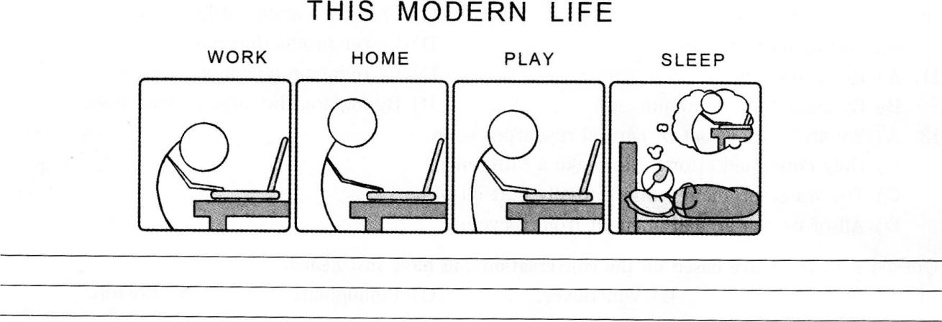

**Part lI Listening Comprehension(30 minutes)**

听力音频地址：<http://wximg.233.com/attached/media/20151113/20151113113756_4292.mp3>

Section A

Directions：In this section，you will hear 8 short conversations and 2 long conversations．At the end of each conversation，one or more questions will be asked about what Was said．Both the conversation and the questions will be spoken only once．After each question there will be a pause．During the pause，you must read thefour choices marked A.，B)，C)and D)． and decide which is the best answer．Then mark the corresponding letter on Answer

Sheet l with a single line through the centre．

1．A.He is pleased to sit on the committee．

B.He iS willing to offer the woman a hand．

C.He will tell the woman his decision later．

D.He would like to become a club member．

2．A.Their planned trip to Vancouver is obviously overpriced．

B.They should borrow a guide book instead of buying one．

C.The guide books in the library have the latest information．

D.The library Can help order guide books about Vancouver．

3．A.He regrets having taken the history course．

B.He finds little interest in the history books．

C.He has trouble finishing his reading assignments．

D.He has difficulty writing the weekly book report．

4．A.The man had better choose another restaurant．

B.The new restaurant is a perfect place for dating．

C.The new restaurant caught her fancy immediately．

D.The man has good taste in choosing the restaurant．

5．A.He has been looking forward to spring．

B.He has been waiting for the winter sale．

C.He will clean the woman，s boots for spring．

D.He will help the woman put things away．

6．A.At a tailor’s．

B.At Bob’s home．

C.In a clothes store．

D.In a theatre．

7．A.His guests favor Tibetan drinks．

B.His water is quite extraordinary．

C.Mineral water is good for health．

D.Plain water will serve the purpose．

8．A.Report the result of a discussion．

B.Raise some environmental issues．

C.Submit an important document．

D.Revise an environmental report．

Questions 9 t0 12 are based on the conversation you have just heard．

9．A.They pollute the soil used to cover them．

B.They are harmful to nearby neighborhoods．

C.The rubbish in them takes long to dissolve．

D.The gas they emit is extremely poisonous．

10．A.Growing population．

B.Packaging materials．

C.Changed eating habits．

D.Lower production cost．

11．A.By saving energy．

B.By using less aluminum．

C.By reducing poisonous wastes．

D.By making the most of materials．

12．A.We are running out of natural resources soon．

B.Only combined efforts can make a difference．

C.The waste problem will eventually hurt all of us．

D.All of us can actually benefit from recyclin9．

Questions l3 to 15 are based on the conversation you have just heard．

13．A.Miami．

B.Vancouver．

C.Belling ham．

D.Boston．

14．A.To get information on one—way tickets to Canada．

B.To inquire about the price of“Super Saver”seats．

C.To get advice on how to fly as cheaply as possible．

D.To inquire about the shortest route to drive home．

15．A.Join a tourist group．

B.Choose a major airline．

C.Avoid trips in public holidays．

D.Book tickets as early as possible．

Section B

Directions：／n this section，you will hear 3 short passages．At the end of each passage，you will hear some questions．Both the passage and the questions will be spoken only once．After you hear a question，you must choose the best answer from the four choices marked A.，B)，C.and D)．Then mark the corresponding letter on Answer Sheet l with a single line through the centre．

Passage One

Questions l6 t0 18 are based on the passage you have just heard．

16．A.There are mysterious stories behind his works．

B.There are many misunderstandings about him．

C.His works have no match worldwide．

D.His personal history is little known．

17．A.He moved to Strat ford—on—Avon in his childhood．

B.He failed to go beyond grammar sch001．

C.He was a member of the town council．

D.He once worked in a well—known acting company．

18．A.Writers of his time had no means to protect their works．

B.Possible sources of clues about him were lost in a fire．

C.His works were adapted beyond recognition．

D.People of his time had little interest in him．

Passage Two

Questions l9 to 21 are based on the passage you have just heard

19．A.It shows you have been ignoring your health

B. It can seriously affect your thinking process

C.It is an early warning of some illness．

D.It is a symptom of too much pressure．

20．A.Reduce our workload．

B.Control our temper．

C.Use painkillers for relief

D.Avoid masking syrup toms_

21．A. Lying down and having some sleep．

B.Rubbing and pressing one’s back．

C.Going out for a walk

D.Listening to light music

Passage Three

Questions 22 t0 25 are based on the passage you have just heard

22．A.Depending heavily on loans．

B.Having no budget plans at all．

C.Spending beyond one's means

D.Leaving no room for large bills

23．A.Many of them can be cut．

B. All of them have to be covered．

C.Their payment cannot be delayed

D.They eat up most of the family income

24．A.Rent a house instead of buying one．

B. Discuss the problem in the family．

C.Make a conservation plan

D.Move to a cheaper Place

25．A.Financial issues plaguing a family．

B.Difficulty in making both ends meet．

C.Family budget problems and solutions

D.New ways to boost family income

Section C

Directions：In this section，you will hear a passage three times．When the passage is read for the first time,you should listen carefully for its general idea． When the passage Its read for the second time,you are required to fill in the blanks with the exact words you have just heard．Finally，when the passage is read for the third time，you should check what you have written．

Perhaps because going to college is so much a part of the American dream，many people go for no 26 reason． Some go because their parents expect it，others because it's what their friends are doing.Then，there，s the belief that a college degree will27 ensure a good job and high pay.

Some students 28 through four years，attending classes，or skipping(逃课)them as the case may be，reading only what can’t be avoided，looking for less 29courses，and never being toucned or changed in any important way． For a few of these people，college provides no 30，yet．Because of parental or peer pressure，they cannot voluntarily leave．They stop trying in the hope that their tea。chers will nmke the decision for them by 31 them．

To put it bluntly (直截了当地)，unless you’re willing to make your college years count，Y0u might be32 doing something else． Not everyone should attend college，nor should everyone who doe．Sattend begin right after high school．Many college students 33 taking a year or so 0ff.A year out m the world helps some people to 34 their priorities and goals．If you’re really going to get something out of going to college，you have to make it mean something，and to do that you must have some idea why you're there，what you hope to get out of it，and35 even what you hope to become.

Part HI Reading Comprehension(40 minutes)

Section A

Directions：／n this section，there is a passage with ten blanks．You are required to select one word for each blank from a list of choices given in a word bank following the passage. Read the passage through carefully before making your choices．Each choice in the bank is identified by a letter．Please mark the corresponding letterfor each item on Answer Sheet 2 with a single line through the centre．You may not use any of the words in the bank more than once．

Questions 36 t0 45 are based on the following passage．

It’s our guilty pleasure：Watching TV is the most comtion everyday activity，after work and sleep， in many parts of the world．Americans view five hours of TV each day，and while we know that spending so much time sitting36 can lead to obesity(肥胖症)and other diseases，researchers have now quantified just how 37 being a couch potato can be．

In an analysis of data from eight large 38 published studies，a Harvard—led group reported in the that for every two hours per day spent channel 39 ，the risk of developing Type 2 diabetes Journal of the American Medical Association(糖尿病)rose 20％over 8．5 years，the risk of heart disease increased l5％over a 40 ，and the odds of dying prematurely 41 13％during a seven— year follow—up．All of these 42 are linked to a lack of physical exercise．But compared with other sedentary(久坐的)activities，like knitting，viewing TV may be especially 43 at promoting unhealthy habits．For one，the sheer number of hours we pass watching TV dwarfs the time we spend on anything else．And other studies have found that watching ads for beer and popcorn may make you more likely to 44 them．

Even so．the authors admit that they didn’t compare different sedentary activities to 45 whether TV watching was linked to a greater risk of diabetes，heart disease or early death compared with，say，reading．

A.climbed

B.consume

C.decade

D.determine

E.effective

F.harmful

G.outcomes

H.passively

I.previously

J.resume

K.suffered

L.surfing

M.term

N.terminals

0.twisting

Section B

Directions：／n this section，you are going to read a passage with ten statements attached to it.Each statement contains information given in one of the paragraphs．Identify the paragraph from which the information is derived．You may choose a paragraph more than once．Each paragraph is marked with a letter．Answer the questions by marking the corresponding letter on Answer Sheet 2．

Essay．Grading Software Offers Professors a Break

A.Imagine taking a college exam，and，instead of handing in a blue book and getting a grade from a professor a few weeks later，clicking the“send”button when you are done and receiving a grade back instantly，your essay scored by a software program．And then，instead of being done with that exam，imagine that the system would immediately let you rewrite the test to try to improve your grade．

B.EDX，the nonprofit enterprise founded by Harvard and the Massachusetts Institute of Technology(MIT)to offer courses on the Internet，has just introduced such a system and will make its automated(自动的)software available free on the Web to any institution that wants to use it．The software uses artificial intelligence to grade student essays and short written answers，freeing professors for other tasks．

C.The new service will bring the educational consortium(联盟)into a growing conflict over the role of automation in education．Although automated grading systems for multiple—choice and true—false tests are now widespread，the use of artificial intelligence technology to grade essay answers has not yet received widespread acceptance by educators and has many critics.

D.Anant Agarwal，an electrical engineer who is president of EDX，predicted that the instant—grading software would be a useful teaching tool enabling students to take tests and write essays over and over and improve the quality of their answers．He said the technology would offer distinct advantages over the traditional classroom system，where students often wait days or weeks lor grades．“There is a huge value in learning with instant feedback，”Dr．Agarwal said．“Students are telling us they learn much better with instant feedback．”

E.But skeptics(怀疑者)say the automated system is no match for live teachers．One longtime critic， Les Perelman，has drawn national attention several times for putting together nonsense essays that have fooled software grading programs into giving high marks．He has also been highly critical of studies claiming that the software compares well to human graders．

F.He is among a group of educators who last month began circulating a petition(呼吁)opposing automated assessment software．The group． which calls itself Professionals Against Machine Scoring of Student Essays in High—Stakes Assessment，has collected nearly 2，000 signatures，including some from famous people like Noanl Chomsky．

G．“Let’s face the realities of automatic essay scorin9，”the group’s statement reads in part. “Computers cannot‘read．’They cannot measure the essentials of effective written communication：accuracy．reasonin9，adequacy of evidence，good sense，ethical(伦理的)position，convincing argument，meaningful organization，and clarity，among others．”

H)But EdX expects its software to be adopted widely by schools and universities．It offers free online classes from Harvard．MIT and the University of California—Berkeley；this fall，it will add classes from Well esley．Georgetown and the University of Texas．In all，12 universities participate in EDX，which offers certificates for course completion and has said that it plans to continue to expand next year，including adding international schools．

I.The EDX assessment tool requires human teachers，or graders，to first grade l00 essays or essay questions．The system then uses a variety of machine—learning techniques to train itself to be able to grade any number of essays or answers automatically and almost instantly．The software will assign a grade depending on the scoring system created by the teacher，whether it is a letter grade or numerical(数字的)rank．

J . EDX is not the first to use the automated assessment technology，which dates to early computers in the l960s．There is now a range of companies offering commercial programs to grade written test answers，and four states--Louisiana，North Dakota，Utah and West Virginia--are using some form

of the technology in secondary schools．A fifth，Indiana，has experimented with it．In some cases the software is used as a“second reader．”to check the reliability of the human graders．

K.But the growing influence of the EDx consortium to set standards is likely to give the technology aboost．On Tuesday，Stanford announced that it would work with EDX to develop a joint educational system that will make use of the automated assessment technology．

L.Two start．ups．Coursera and Udacity，recently founded by Stanford faculty members to create“massive open online courses，”0r MOOCs，are also committed to automated assessment systems because of the value of instant feedback．‘‘It allows students to get immediate feedback on their

work．so that learning turns into a game，with students naturally gravitating(吸引)toward resubmitting the work until they get it right，”said Daphne Koller，a computer scientist and afounder of Coursera．

M．Last year the Hewlett Foundation， a grant—malting organization set up by one of the Hewlett Packard founders and his wife．sponsored two$100，000 prizes aimed at improving software that grades essays and short answers．More than l50 teams entered each category．A winner of one of the Hewlett contests．Vik Paruchuri，was hired by E(Ⅸto help design its assessment software．

N．“One of our focuses is to help Mds learn how to think critically，”said Victor Vuchic，a program officer at the Hewlett Foundation．“It’s probably impossible to do that with multiple—choice tests The challenge is that this requires human graders，and so they cost a lot more and they take a lot more time．“

O．Mark D．Shermis，a professor at the University of Akron in Ohi0．supervised the Hewlett Foundation’s contest on automated essay scoring and wrote a paper about the experiment．In his view，the technology--though imperfect--has a place in educational settings．

P．With increasingly large classes，it is impossible for most teachers to give students meaningful feedback on writing assignments，he said．Plus，he noted，critics of the technology have tended to come from the nation’s best universities，where the level of teaching is much better than at n lost schools．

Q)“Often they come from very famous institutions where，in fact，they do a much better．job of providing feedback than a machine ever could，”Dr．Shermis said．“There seems to be a lack of appreciation of what is actually going on in the real world．”

46．Some professionals in education are collecting signatures to voice their opposition to antomated essay grading．

47．Using software to grade students’ essays saves teachers time for other work．

48．The Hewlett contests aim at improving essay grading software．

49．Though the automated grading system is widely used in multiple—choice tests．automated essay grading is still criticized by many educators．

50．Some people don’t believe the software grading system can do as good a job as human graders．

51．Critics of automated essay scoring do not seem to know the true realities in less famous universities．

52． Critics argue many important aspects of effective writing cannot be measured by computer rating programs．

53．As class size grows，most teachers are unable to give students valuable comments aS to how to improve their writin9．

54．The automated assessment technology is sometimes used to double check the work of human graders．

55．Students find instant feedback helps improve their learning considerably．

Section C

Directions：There are 2 passages in this section．Each passage is followed by some questions or unfinished statements．For each of them there are four choices marked A.，B)，C)and D.You should decide on the best choice and mark the corresponding letter on Answe，．

Sheet 2 with a single line through the centre．

Passage One

Questions 56 t0 60 are based on the following passage．

The endless debate about“work—life balance”often contains a hopeful footnote about stay at home dads．If American society and business won’t make it easier on future female leaders who choose to have children，there is still the ray of hope that increasing numbers of full—time fathers will．But based on today’s socioeconomic trends，this hope is，unfortunately，misguided．

It’s true that the number of men who have left work to do their thing as full—time parents has doubled in a decade，but it’s still very small：only 0．8％of married couples where the stay—at—horne father was out of the labor force for a year．Even that percentage is likely inflated by men thrust into their caretaker role by a downsizing．This is simply not a large enough group to reduce the social stigma(污名)and force other adjustments necessary to supporting men in this decision．even if onlywork more than their family．

Even shorter times away from work for working fathers are already difficult．A study found that 85％of new fathers take some time off after the birth of a child—but for all but a few．it’s a week or two at most．Meanwhile，the average for women who take leave is more than lo weeks．

Such choices impact who moves up in the organization．While you’re away，someone else is doing your work，making your sales，taking care of your customers．That can’t help you at work．It can only hurt you．Women，of course，face the same issues of returning after a long absence．But with many more women than men choosing to leave the workforce entirely to raise families，returning from an extended parental leave doesn’t raise as many eyebrows as it does for men．

Women would make more if they didn’t break their earning trajectory(轨迹)by leaving the workforce，or if higher-paying professions were more family friendly．In the foreseeable future，Stay at home fathers may make all the difference for individual families．but their presence won’t reduce the numbers of high potential women who are forced to choose between family and career．

56．What gives women a ray of hope to achieve work life balance?

A.More men taking an extended parental leave．

B.People’s changing attitudes towards family．

C.More women entering business management．

D.The improvement of their socioeconomic status．

57．Why does the author say the hope for more full—time fathers is misguided?

A.Women are better at taking care of children．

B.Many men value work more than their family．

C.Their number is too small to make a difference．

D.Not many men have the chance to stay at home．

58．Why do few men take a long parental leave?

A.A long leave will have a negative impact on their career．

B.They just have too many responsibilities to fulfill at work．

C.The economic loss will be too much for their family to bear．

D.They are likely to get fired if absent from work for too lon9．

59．What is the most likely reaction to men returning from an extended parental leave?

A.Jealousy．

B.Surprise

C.Admiration

D.Sympathy．

60．What does the author say about high-potential women in the not—too-distant future?

A.They will benefit from the trend of more fathers staying at home．

B.They will find high—paying professions a bit more family—friendly．

C.They are unlikely to break their career trajectory to raise a family．

D.They will still face the difficult choice between career and children．

Passage Two

Questions 61 tO 65 are based on the following passage．

Some of the world’s most significant problems never hit headlines．One example comes from agriculture．Food riots and hunger make news．But the trend lying behind these matters is rarely talked about．This is the decline in the growth in yields of some of the world’s major crops．A new study by the University of Minnesota and McGill University in Montreal looks at where．and how far．this decline is occurring．

The authors take a vast number of data points for the four most important crops：rice，wheat，corn and soyabeans(大豆)．They find that on between 24％ and 39％ of all harvested areas，the improvement in yields that took place before the l980s slowed down in the l990s and 2000s．There are two worrying features of the slowdown．One is that it has been particularly sharp in the world’s most populous(人口多的)countries，India and China．Their ability to feed themselves has been an important source of relative stability both within the countries and on world food markets．

That self-sufficiency cannot be taken for granted if yields continue to slow down or reverse．Second，yield growth has been lower in wheat and rice than in coll and soyabeans．This is problematic because wheat and rice are more important as foods，accounting for around half of all calories consumed．Corn and soyabeans are more important as feed grains．The authors note that“we have preferentially focused our crop improvement efforts on feeding animals and cars rather than on crops that feed people and are the basis of food security in much of the world．”

The report qualifies the more optimistic findings of another new paper which suggests that the world will not have to dig up a lot more land for farming in order to feed 9 billion people in 2050，as the Food and Agriculture Organisation has argued． Instead，it says，thanks to slowing population growth，land currently ploughed up for crops might be able to revert(回返)to forest or wilderness．This could happen．The trouble is that the forecast assumes continued improvements in yields which may not actually happen

61．What does the author try to draw attention to?

A.Food riots and hunger in the world．

B.News headlines in the leading media．

C.The decline of the grain yield growth．

D.The food supply in populous countries．

62．Why does the author mention India and China in particular?

A.Their self-sufficiency is vital to the stability of world food markets．

B.Their food yields have begun to decrease sharply in recent years．

C.Their big populations are causing worldwide concerns．

D 1 Their food self-sufficiency has been taken for granted．

63．What does the new study by the two universities say about recent crop improvement efforts?

A. They fail to produce the same remarkable results as before the l980s．

B.They contribute a lot to the improvement of human food production．

C.They play a major role in guaranteeing the food security of the world．

D.They focus more on the increase of animal feed than human food grains．

64．What does the Food and Agriculture Organisation say about world food production in the coming decades?

A.The growing population will greatly increase the pressure on world food supplies．

B.The optimistic prediction about food production should be viewed with caution．

C. The slowdown of the growth in yields of major food crops will be"reversed．

D.The world will be able to feed its population without increasing farmland．

65．How does the author view the argument of the Food and Agriculture Organisation?

A.It is built on the findings of a new study．

B.It is based on a doubtful assumption．

C.It is backed by strong evidence．

D. It is open to further discussion．

Part IV Translation(30 minutes)

Directions：For this part，you are allowed 30 minutes to translate a passage from Chinese into English．You should write your answer on Answer Sheet 2．

据报道，今年中国快递服务(courier services)将递送大约120亿件包裹。这将使中国有可能超越美国成为世界上最大的快递市场。大多数包裹里装着网上订购的物品。中国给数百万在线零售商以极具竞争力的价格销售商品的机会。仅在ll月11日，中国消费者就从国内最大的购物平台购买了价值90亿美元的商品。中国有不少这样的特殊购物日。因此，快递业在中国扩展就不足为奇了。

2015年6月大学英语四级考试真题答案与详解

(第2套)

Part I Writing



这是一篇四级考试中常见的议论文。此次通过漫画所呈现出的话题computer(电脑)是考生日常生活中耳熟能详的话题，因此写起来并不难。行文中，考生应将重点放在第二段阐述电脑与日常生活的关系上。联系实际分析可知，二者关系为：电脑为日常生活提供了便利，但不能完全占据人们的日常生活。



一、提出观点：电脑在日常生活中虽然重要但并非必不可少(an important but not indispensable role)

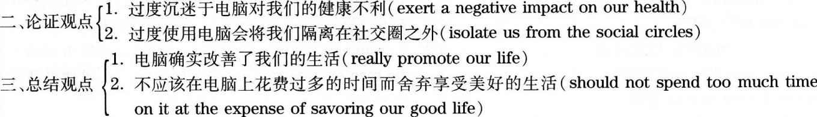



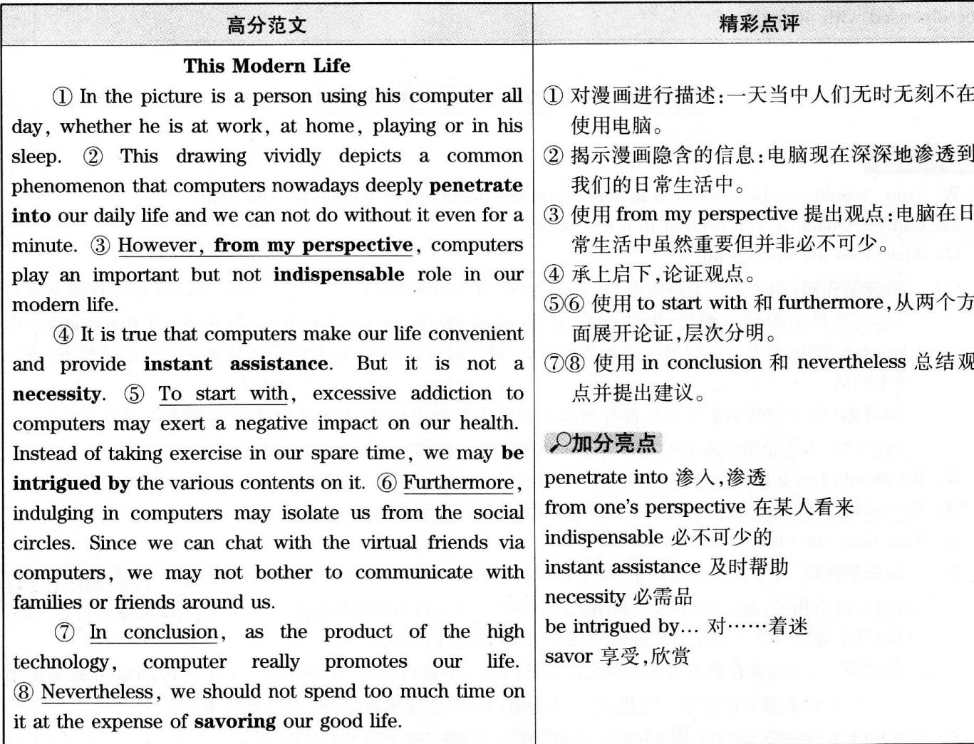



现代生活

漫画中是一个人，一天当中他无时无刻不在使用电脑，不论是在工作时、在家时、玩游戏时，还是在睡眠中。这幅漫画生动地描述了一种普遍现象：电脑现在深深地渗透到我们的日常生活中，我们甚至一分钟都不能没有它。尽管如此，在我看来，电脑在现代生活中虽然重要但并非必不可少。

诚然，电脑使我们的生活方便，并提供及时帮助。但它并非生活必需品。首先，过度沉迷于电脑对我们的健康不利。我们可能着迷于电脑上五花八门的内容而忽略了在业余时间锻炼身体。此外，过度使用电脑会将我们隔离在社交圈之外。因为我们可以通过电脑与虚拟世界中的朋友交谈，所以我们可能不会费心去与身边的亲朋好友交流。

总之，作为高科技的产物，电脑确实改善了我们的生活。但是我们不应该在电脑上花费过多的时间而舍弃享受美好的生活．



|  |  |
| --- | --- |
| 主题词汇  make good use of充分利用  be fascinated by着迷于  illustrate阐述，阐释  information highway信息高速  extend…int0将……扩展到  attach importance to重视  key pal网友  digital数字的，数码的  be obsessed with沉迷于 | 句式拓展  1．For a long time many people would like to type…on  the computer rather than conceive of…长期以来，许  多人宁愿把……打在电脑上，而不是自己构思…….  2．It is human beings themselves wh0…．which makes  the high technology…正是人类自身……，这使得高科．  技……。 |

Part II Listening Comprehension



1．W：Tom．would you be interested in serving on the membership committee this year?

M：Can I get back to you on that in a few days?

0：What does the man mean?

C.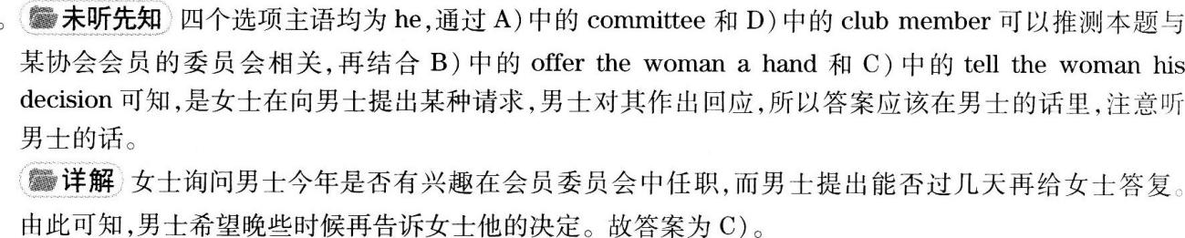

2．W：We should buy a good guide book and study it before our trip to Vancouver．

M：We could．But they are overprice—d．What about the library?

Q：What does the man mean?

B.

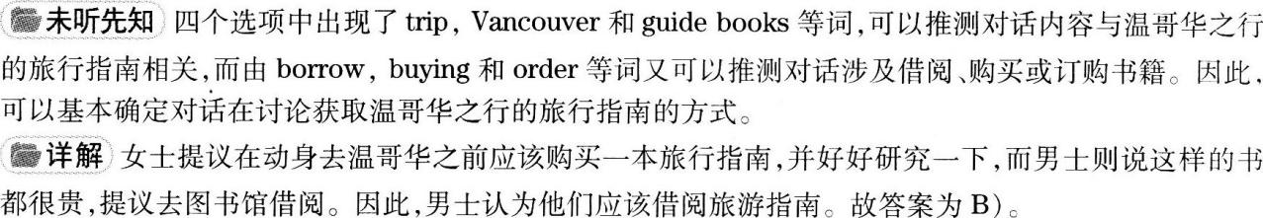

3．W：You took a history course this term．didn’t you?What can you say about it?

M：Well,the trouble is that I never get through the weekly r—eadin—g list，though some books are quite interesting．

Q：What does the man mean?

C.



assignments，difficulty和book report等，由此可推测对话内容与男士在历史课上所碰到的问题相关。男士的话是解题的关键，需要特别注意。



4．M：I'm taking my girlfriend to the fancy new restaurant for her birthday tonight．

W．1 went there last weekend．I found it rather disappointing．

Q：What does the woman mean?

A.

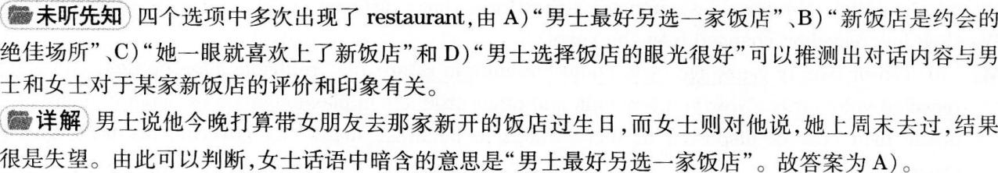

5．W：Winter is over at last．Wiine to put away my gloves and boots．

M：I've been waiting for this for months．

Q：What does the man mean?

A.

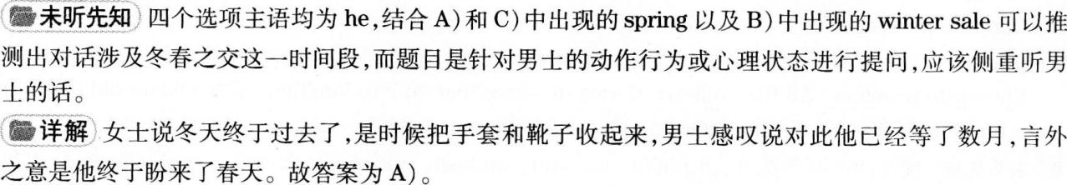

6.M．Look,the curtain is going up slowly and all the lights over the—stage are—lit up．

W：Yeah，the play is staring．Oh，something caught my sleeve．Give me a hand please，Bob．

Q：Where are the speakers now?

D.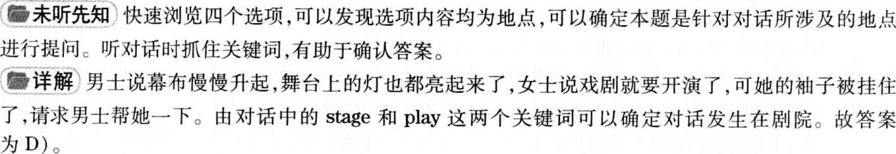

7．W：You only have water to serve your guests?

M：This isn't just plain water．This is mineral water.this is mineral water from Tibet．

Q：What does the man imply?

B.

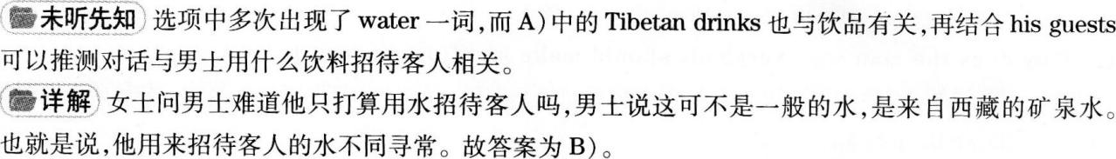

8．W：When do you have time to discuss our environmental report?I think we will have to make some revisions．

M：I'll be free at 3 0'clock this afternoon．But what exactly needs to be changed?

Q：What are the speakers going to do this afternoon?

D.



W：Why is it important to recycle?

M：There are many reasons．Recycling is one way to keep waste out of landfills．Landfills are places to dump waste．(9)But they are unpopular,because they can pollute the soil used to cover them and that's bad for people who may build new homes there．Recycling also reuses valuable raw materials，such as aluminum and paper．Finally，recycling Can leave a lower garbage bill． Recycling lowers the amount of waste put into landfills，therefore，less money is spent for garbage disposal．

W：How has recycling changed over the years?

M：(10)Ten or twenty years ago,you could buy milk in returnable,refillable glass bottles,and many people—recycled voluntarily． Now you buy milk and other products in plastic bottles or paper containers．Because of the high cost of disposing of these things in landfills，many city governments now have recycling programs．

W：How does recycling help the environment?

M：(11)Recycling helps the environment mainly by saving energy．For example，it takes 95 percent less energy to produce recycled aluminum than to produce new aluminum.

W：Can one person really make a difference?If only a few people recycle，then what’S the point?

M：If not you，then who?(12)1f we combine our efforts,we can make a difference．Each of us contributes to the waste problem．All the millions of tons of waste that go into landfills started as 32l old pair of slippers， a broken TV set．or a used magazine that came from somebody’S house--maybe yours !



9．Why are landfills unpopular according to the man?

A.



10．What does the man say has contributed to the increasing amount of waste over the years?

B.



11．According to the man，how does recycling help the environment?

A.



12．Why does the man say everybody should make ail effort to recycle?

B.





W :l3)Could you please give me information on airfares from Miami to Bellingham,Washington?(14)We．'d 1ike to buy somehow good flight as cheaply as possible．

M：Let，s see．1 want to advise you to Pay the nonnal one—way economy class fare of$555．(15)1f you can fly On a Tuesd a or Wednesday and buy your tickets at least 2 1 days in advance,I suggest you book a round trip excursion flight．

W：But we may not need the return tickets．

M：That，s all right．Even if you don’t use them，you should be able to save$89 0ver the one’way fare. (15)Of course．I'd recommend early booking.You ought to try to reserve the“Super Saver”seats．There are only a few of them and they are 50％cheaper than the others．

W：That sounds like a good idea.

M：Wait，to save another hllndred dollars or s0，why don’t you book a flight to Vancouver，Canada?

W：But that’S farther than where we want to 90．

M：I know，but you can take a bus from Vancouver back to Bellingham and still save money.And if you are trayellin9with children，you might be able to get a discount if you fly economy class.But they don’t get any discount．(15)But to take the advantage of the airline's guarantee fare policy,you'd have to make reservations and pay for your tickets at least 6 weeks in advance．Try and begin the search for able seats．．

W：N0，thank you．

M：Excuse me?

W．I may Pall VOU back if we don’t decide to drive．



13．Where is the woman planning to go?

C)。



14．What is the woman’S purpose in calling the man?

C)。



15．What does the man advise the woman to do?

D.







What makes a Derson famous?This is a mystery that many people have carefully thought about.All kinds of myths surround the lives of well—known people．Most people are familiar with the works of William Shakespeare，one of the greatest EngUsh writers of the l6th and l7th centuries．(16)Yet how many know Shake speare the person,the man behind the works?After centuries of research,scholars are still trying to．discover Shakespeare's personal history．It is not easily found in his writings． Authors of the time could not protect their works．An acting company，for example，could change a play if they wanted t0.Nowadays，writers have copyrights that protect their work．

Many myths arose about Shakespeare．Some said he had no formal education·Others believe that he began his career by tending the horses of wealthy men．All of these myths are interesting，but are they time?Probably not．(17)Shakespeare's father was a respected man in Stratford-on-Avon,a member of the town． council．He sent young William to grammar sch001．Most people of Elizabethan times did not continue beyond grammar school；s0，Shakespeare did have，at least，an average education．(18)Some parts of Shakespeare's 1ife will always remainun known．The Great London Fire of l666 burned many important documents that could have been a source of clues．We will always be left with many questions and few facts．



16．What does the speaker say about William Shakespeare?

D.



17．What do we learn about Shake speare’S father?

C.



听录音时应注意将选项和短文内容进行匹配区别。短文中提到莎士比亚的父亲受人尊敬，是埃文河畔斯特拉特福镇议会的一名成员。故C)为答案。

18.Why does the speaker say parts of Shakespeare’s life will remain a mystery?

B.





Almost everyone suffers from a headache occasionally．But some people suffer from repeated，frequent headaches．(19)A—headache is important because it can be the first warning of a serious condition that could probablv be controlled if discovered early．If a person removes the warnin9，day after day，、Ⅳ1th a painkiller，he or she may pass the point of easy contr01．The professional nalne for covering up a symptom is“maskin9·

(20)A headaches pecia1ist 0nce—said,"Masking symptoms is not the best way of treatment．Sometimes it is wiser to stand still than to advance in darkness．”A headache often interferes needlessly with normal，happy livin9．The employee with a headache does less work．In a flash of temper he or she may upset fellow workers or customers．causing a direct or indirect loss to the organization．The mother with a headache suffers and

disturbs the family．She upsets her husband and children．Rest，quiet，and flesh air stop many common headaches．(21)Lying down and possibly falling asleep may help．One can often handle tension headaches by rubbing and pressing back neck muscles．Heat from an electric pad or a warnl bath can also help．Because hunger may be overlooked as a headache source，one must make a habit of regular meals．If a meal must be postponed for more than all hour，a snack helps to avoid a hunger headache．



19．Why does the speaker say a headache is important?

C.



20．What do specialists suggest we do with headaches?

D.



21．What does the speaker say helps relieve the symptoms of common headaches?

A.





( 25)1f your pay check seems to be disappearing into thin air,you may be stuck in money traps．But don't despair．Most people can get unstuck without going bankrupt．(22)The biggest budget mistake is no budget at a11．As one reader put it．we just put all the bills in a pile，and try to decide which to Pay．As she and others have learned，however，the money usually runs out before the bills d0．The same problem plagues many who do have budget．In letter after letter we read，“It looks good on paper，but it never seems to work．”Why not? Often because the budgets are unrealistic．The solution：Make a detailed record of where all your money goes now：then study it carefully．Look for expenses that can be cut back．(23)And don't give up in the face of high fixed expenses．Many of these can be reduced too． In fact，it’s often easier to save on essentials than on enjoyable extras．(24)1f housing takes more than 25 percent of your income,for example,consider moving to a cheaper place．or renting out an extra room．If utility bills are high，get the whole family involved in a conservation plan． Some bills can be eliminated altogether． When one mother realized that cable TV was costing her$500 a year．she decided that network TV wasn’t so bad．If you question every expense，you Can

find a few that can be reduced．



初步判断短文与财务问题相关，由第22题的四个选项可以了解到短文以家庭财务困境开篇，而接下来第24题各选项给出了一些建议，由此可知文章针对开篇所提到的财务困难给出了解决方案。

22.what does the speaker say is the biggest budget mistake?

B.



23．What does the speaker say about the SO-called fixed expenses?

A.



24．What does the speaker suggest people do to save housing expenses?

D.



25．What is mainly discussed in the talk?

C.





26．particular。



27．automatically。



28．drag。



29．demanding。



30．satisfaction。



31．



32．



33．



34．



35．



Part III Reading Comprehension



在世界上许多地方，工作和睡觉之余，看电视是最常见的日常活动，这是令我们感到愧疚的娱乐活动。美国人每天看5个小时的电视，并且尽管我们知道花这么多时间(36)消极地坐着会导致肥胖症和其他疾病，研究者们现在已经对长时间看电视的(37)危害得出了量化结果。

通过分析8个(38)先前发布的大型研究数据，一个哈佛大学领导的小组在《美国医学协会期刊》上报告称，每天花两个小时(39)频繁更换电视频道，八年半内患Ⅱ型糖尿病的风险增加了20％，(40)十年内患心脏病的风险增加了l5％，而且一项为期七年的跟踪调查发现过早死亡的几率(41上升了13％。所有上述(42)结果都与缺乏体育锻炼有关。不过，与其他久坐不动的行为比起来，比如织毛衣，看电视可能在促成不健康的习惯方面尤其

(43)有效原因之一是我们花在看电视上的时间远超过我们花在任何其他事情上的时间。另外，其他研究表明，观看啤酒和爆米花的广告使人更有可能(44)食用它们。

即便如此，作者们承认他们没有比较不同的久坐不动的活动以(45)确定看电视是否有更高的风险患糖尿病、心脏病或过早死亡，比如与读书相比。



名词：C)decade十年；

G)outcomes结果；

L)surfing频繁更换；浏览互联网；

M)term术语；学期；

N)terminals航空站，终点站

动词：A)climbed上升，攀爬；

B)consume吃，喝，消耗；

D)determine确定，决定；

J)resume重新开始；

K)suffered受折磨，遭受；

L)surfing频繁更换；浏览互联网；

M)term把……叫作；

0)twisting使弯曲，歪曲

形容词：E)effective有效的；

F)harmful有害的

副词：H)passively消极地；

I)previously先前



36．



37．

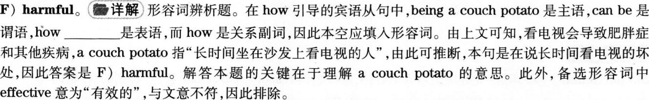

38．



39．



40．



41．



42．



43．

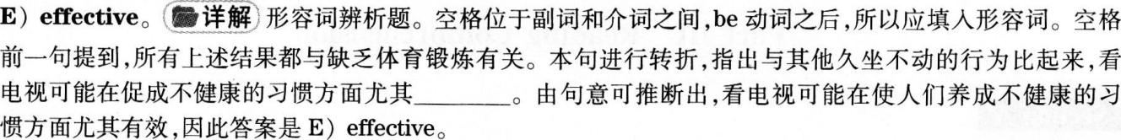

44．



45．





短文评分软件给教授减压

A)设想参加一次大学考试，做完试题后不是上交考卷并在几个星期后拿到教授的评分，而是点击“发送’’按钮并立即收到一个分数——一个由软件程序对你短文的评分。然后，设想考试不是就此结束，而是系统立即让你重新答题以取得更好的成绩。

B)EDX——由哈佛大学和麻省理工学院共同成立的提供在线课程的非营利性组织——已经引入了这样一个系统，并将在网上推出免费的自动化软件供任何想要使用的机构使用。(47)该软件利用人工智能对学生的短文和简答题进行评分，从而将教授们解放出来以开展其他工作。

C)这一新的服务将会使教育联盟陷入有关自动化在教育中所扮演角色的更激烈的争论。(49)虽然现在针对选择题和判断正误题的自动评分系统已经非常普遍，但利用人工智能技术对短文进行评分尚未得到教育工作者的广泛认可，而且批评声也很多。

D)EDX总裁兼电子工程师阿南特·阿加瓦尔预测说，即时评分软件将会是一个有益的教学工具，可以让学生反复测试和写作，并提高答案的质量。他表示，相比于传统的课堂系统——学生通常要等数天乃至数周才能拿到分数，该技术有着明显的优势。(55)“学习中即时反馈有着巨大价值，”阿加瓦尔博士说，“学生们告诉我们说有了即时反馈，他们学得更好。”

E)但怀疑人士表示，自动化系统比不上活生生的老师。莱斯·佩雷尔曼就是一位长期的批评者，并曾多次引起全国关注，原因是他将文理不通的短文组合在一起，而软件评分程序不明就里，给出了很高的分数。(50)此外，对于有关软件评分优于人力评分的研究，他也持强烈的批评态度。

F)(46)从上个月起，由教育工作者组成的一个团体开始散发反对自动化评估软件的请愿书，而他就是其中的参与者之一。该团体自称是“反对重要测试中使用机器对学生作文进行评分的专业人士”，现已收集到了近2，000个签名，其中也包括一些知名人士，如诺姆·乔姆斯基等。

G)“让我们面对自动化短文评分的事实，”该团体声明中有部分写道，“计算机不能‘阅读’。(52)它们无法衡量有效书面表达的基本要素：准确性、逻辑、充足的论据、完整的意义、伦理立场、令人信服的论证、有意义的结构和清晰性等等。”

H)但EDX期望它的软件能够为学校和大学广泛采用。EDX提供哈佛大学、麻省理工学院和加州大学伯克利分校的免费在线课程；今年秋天，它还将增加卫尔斯利学院、乔治城大学和得克萨斯大学的课程。总计有12所大学参与EDX，它提供结业证书，并表示计划在明年继续扩大规模，包括增加国际学校。

I)EDX评估工具需要实实在在的老师或评分者首先评判100份短文或问答题。然后，该系统利用多种机器学习技术进行自我培训，以便以一种近乎即时的方式对众多短文或答案进行自动评分。该软件会基于老师所创建的评分系统给予一个分数，可能是字母等级，也可能是数字分数。

J)EDX并不是最先使用自动化评估技术的机构，这种技术可追溯到20世纪60年代的早期计算机。目前，一系列公司已经推出了书面阅卷的商用程序，而且四个州——路易斯安那、北达科他、犹他和西弗吉尼亚——已经在中学使用该技术的某种形式。第五个州——印第安纳州已经开始试行。(54)在某些情况下，该软件充当了“第二阅卷者”的角色，用来检验人工评分的可靠性。

K)但是，EDX集团设定标准的影响力的上升可能会推进这一技术的应用。周二，斯坦福大学宣布它将会与EDX合作开发一个联合教育系统，并将利用自动化评估技术。

L)此外，近期成立的Coursera和Udacity是斯坦福大学教职人员为创建“大型公开在线课程”(MOOCs)而成立的两家新兴机构，鉴于即时反馈的价值，它们也承诺采用自动化评估系统。“它会对学生的功课做出即时反馈，这样一来，学习就会变成一种游戏，自然而然地吸引学生反复提交作业，直到正确为止，”计算机科学家、Coursera公司创始人达芙妮·科勒说。

M)(48)去年，休利特基金会——由惠普公司创始人之一及其妻子成立的捐赠型组织——赞助了两个l0万美元的奖项，旨在对短文和简答题评分软件进行改进。每个奖项的参赛团队都超过了150个。此次休利特竞赛之一的获胜者维克·帕鲁丘里被EdX聘去帮助设计评估软件。

N)“我们的关注点之一是帮助孩子们学会批判性思考，”休利特基金会项目官员维克多．维奇克说。“选择题测试不可能达到那种效果。挑战在于，这需要人力评分，所以成本更大，而且耗费时间也更长。”

O)俄亥俄州阿克伦大学教授马克·D．舍米斯是休利特基金会短文自动评分竞赛的监督者，而且还就这次试验写过一篇论文。在他看来，这一技术虽然并不完美，但在教育环境中还是占有一席之地的。

P)(53)他说，随着班级规模的不断扩大，大多数老师都不太可能就学生的作文给出有意义的反馈。另外，他还指出，关于该技术的批评者多来自全美顶尖大学，那里的教学水平要比大多数学校高得多。

Q)“他们通常都来自非常著名的机构，事实上，他们给出的反馈的确优于机器的反馈，”舍米斯博士说。(51)“但是他们似乎缺乏对现实世界中真实情况的了解。”



46．

Some professionals in education are collecting signatures to voice their opposition to automated essay grading．



F)He iS anlong a group of educators who last month began circulating a petition (呼吁) opposing automated assessment software．The group，which calls itseff Professionals Against Machine Scoring of Student Essays in High—Stakes Assessment，has collected nearly 2，000 signatures，including some from famous people like Noanl Chomsky．



47．Using software to grade students’essays saves teachers time for other work．

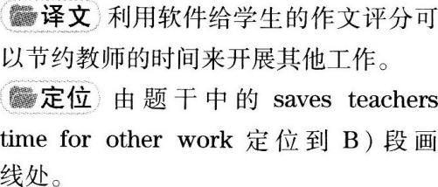

B)EDX．the nonprofit enterprise founded by Harvard and the Massachusetts Institute of TechnologY(MIT)to offer courses on the Internet．has just introduced such a system and will make its automated(自动的)software available free on the Web to any institution that wants to use it． The software uses artificial intelligence to grade student essays and short written answers,freeing professors for other tasks

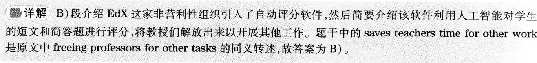

48．The Hewlett contests aim at improving essay grading software．

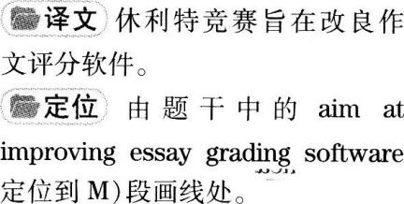

M)Last year the Hewlett Foundation，a grant—making organization set up by one of the Hewlett—Packard founders and his wife． sponsored two $100．000 prizes aimed at improving software that grades essays and short answers．More than 150 teams entered each category．A winner of one of the Hewlett contests，Vik Paruchuri，was hired by EDX to help design its assessment software．

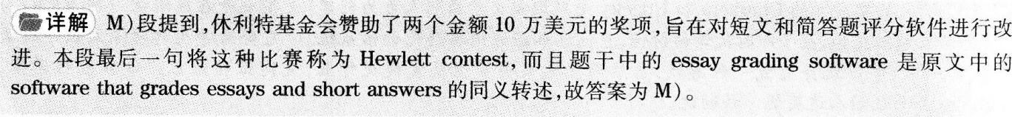

49．Though the automated grading system is widely used in multiple—choice tests automated essay grading is still criticized by many educators．

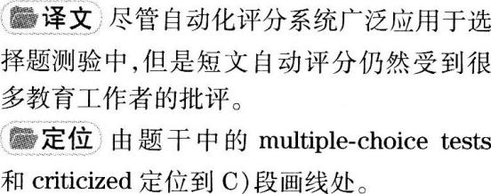

C)The new service will bring the educational consortium(联盟)into a growing conflict over the role of automation in education．Although automated grading systems for multiple．．choice and true—false tests are now widespread，the use of artificial intelligence technology to grade essay answer．Has not yet received widespread acceptance by educators and has many critics．



50．Some people don’t befieve the software grading system can do as good a job as human graders．

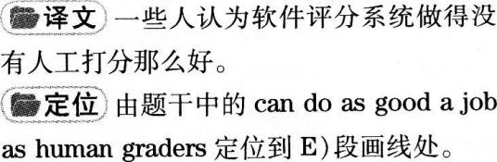

E)But skeptics(怀疑者)say the automated system is no match for live teachers． One longtime critic，Les Perelman，has drawn national attention several times for putting together nonsense essays that have fooled software grading programs into giving high marks．He has also been highly critical of studies claiming that the software c0mpares well to human graders．

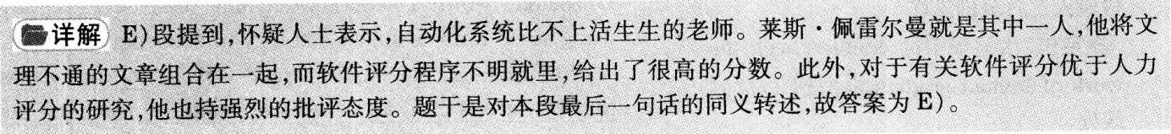

51．Critics of automated essay scoring do not seem to know the true realities in less famous universities．



Q)“Often they come from very famous institutions where， in fact，they do a much better job of providing feedback than a machine ever could，”Dr．Shermissaid．"There seems t0 bealack 0f appreciation of What is actually going on in the real world"．

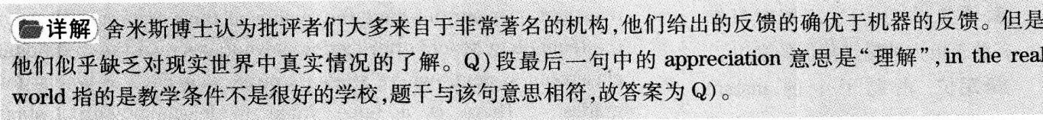

52．Critics argue many important aspects of effective writing cannot be measured by computer rating programs．

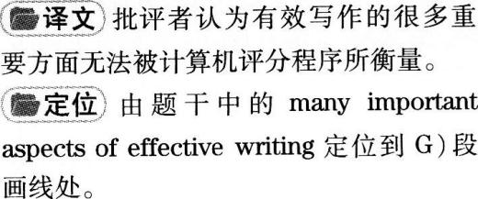

G)“Let’S face the realities of automatic essay scorin9，”the group’S statement reads in part．“Computers cannot ‘read’They cannot measure the essentials o effectivewrittenc0mmnicati0n；accuracy, reas0，ningade quacy of evidence,good sense,ethical (伦理的)position，convincing argument，meaningful organization,and clarity among others．"．

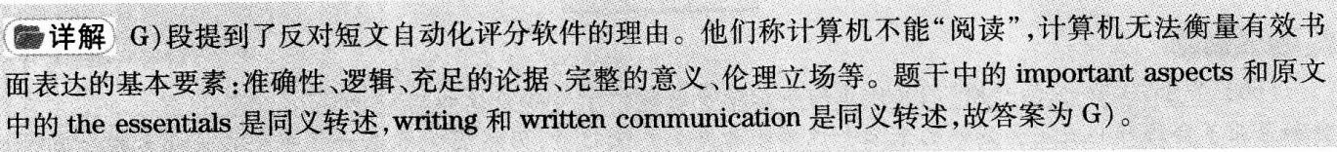

53．As class size grows，most teachers are unable to give students valuable comments as to how to improve their writin9．



P)Withincreasingly large classes,it is impossible for m0stteachersto9ivestudents meaningful feed backon writing assignments,he said．Plus，he noted，critics of the technology have tended to come from the nation’S best universities，where the level of teaching is much better than at most schools．

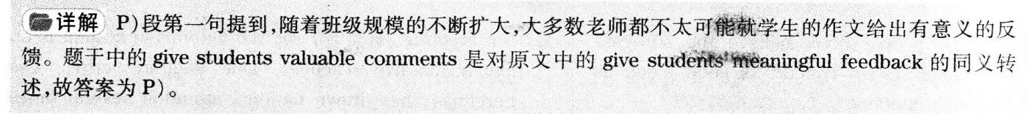

54．The automated assessment technology is sometimes used to double check the work of human graders．

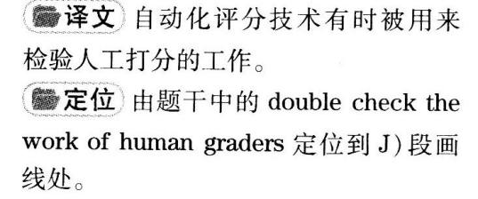

J)EDX is not the first to use the automated assessnlent technology，which dates to early computers in the l960s． There is now a range of companies offering commercial programs to grade written test answers．and four states Louisiana，North Dakota，Utah and West Virginia--are using some form of the technology in secondary schools． A fifth。Indiana．has experimented with it．In some cases the software is used as a"second reader,"to check the reliability of the human graders．

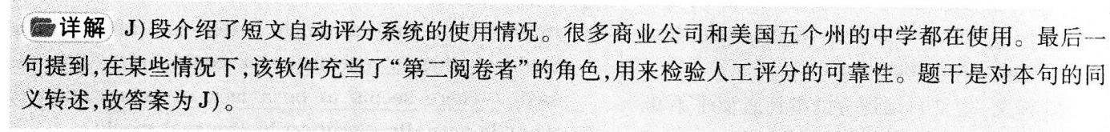

55．Students find instant feedback helps improve their learning considerably．

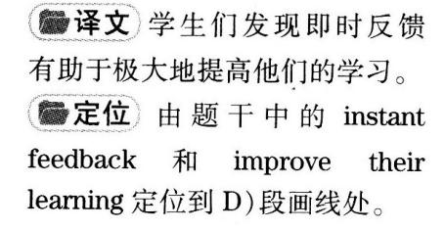

D)Anant Agarwal，an electrical engineer who is president of EDX． predicted that the instant—grading software would be a useful teaching tool，enabling students to take tests and write essays over and over and improve the quality of their answers．He said the technology would offer distinct advantages over the traditional classroom systern．where students often wait days or weeks for grades． “There is a huge value in learning with instant feedback，”Dr．Agarwal said．“Students are telling as they learn much better with instant feedback．”









(56)关于“工作-生活平衡”的无休止的争论经常包括一个给人希望的注释，那就是全职父亲。如果美国社会和企业不会给那些决定当妈妈的未来女性领导者更多方便的话，仍然能够带来一丝希望的是越来越多的全职父亲会给她们更多便利。(57)但是基于现在的社会经济趋势，不幸的是，这种希望是被误导的。

(57)近十年里放弃工作成为全职父亲的人数翻倍的确是事实，但是这个数字仍然很小：已婚家庭中只有0．8％的全职父亲能够坚持离开工作岗位长达一年时间。甚至这个比率中还包含着因为企业精简裁员而不得不退居家庭的男士。要减少社会污名，这个群体根本不够大，而且需要迫使做出其他必要的调整来支持男性做出这个决定，即使是在相对短的时间内。

对于上班族父亲而言，即使是更短一点时间不工作都是困难的。一项研究发现85％的新生儿父亲会在孩子刚出生之后休息一段时间——但总共仅仅几天，最多一至两个星期。同时，产后的女性平均会休息十周以上的时间：

(58)这样的选择会影响到那些在组织中希望晋升的人。当你离开的时候，其他人会承担你的工作，替你完成销售，照顾你的客户。这些并不能有助于你的工作。这只能伤害你。当然，女性在很长时间的脱岗之后回岗会面临相同的问题。(59)但是，由于相比男性，会有更多的女性选择完全离职来照顾家庭，所以休完延长的产假之后堕归工作的女性所引起的惊讶并不会多于男性。

如果女性员工离开工作而不切断自己的职业轨迹的话，或者高薪职业更有利于家庭生活，她们会得到更多。(60)在可以预见的未来，全职父亲可能会给个体家庭带来改变，但是他们的存在并不能减少那些在工作和家庭之间被迫做选择的很有潜力的女性的数量。



56．B.

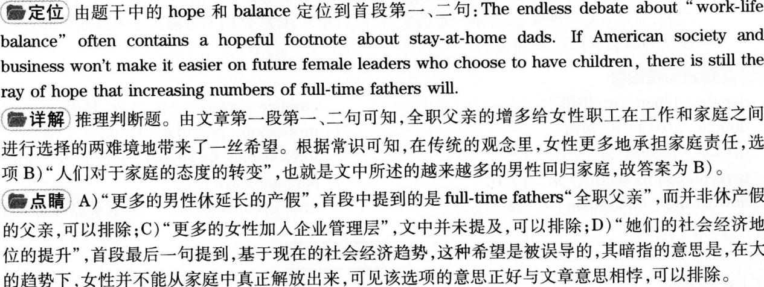

57．C.

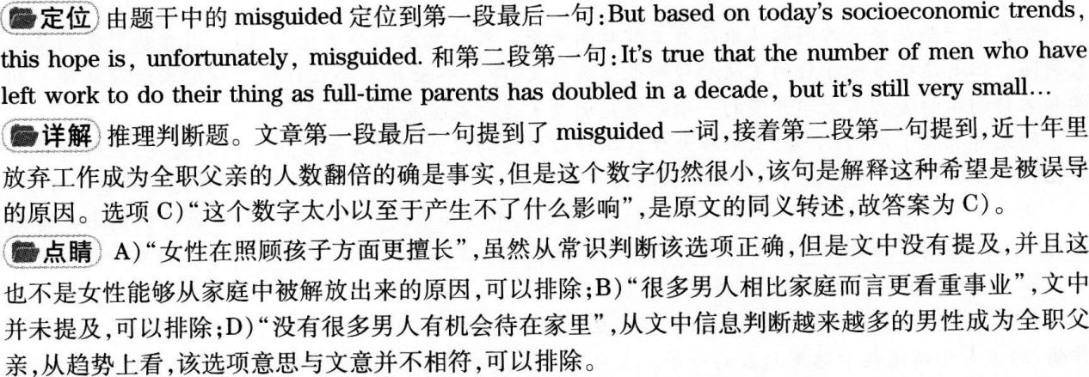

58．A.

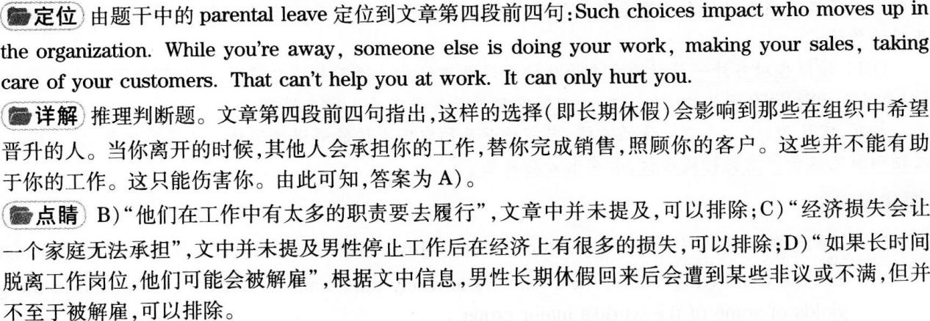

59．B.

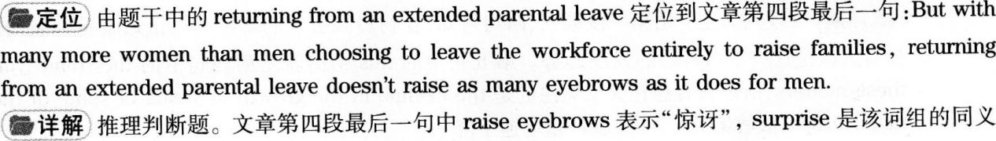

转述，故答案为B.



60．D)．

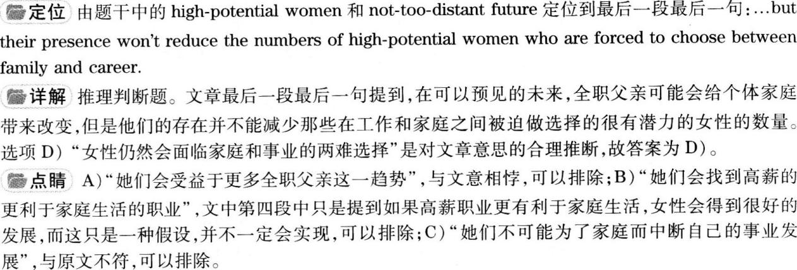



debate[dl’belt]n.争论

double[’dAb01]v．翻倍

decade[1dekeld]n.十年

percentage[p0’sentId]n．百分比

downsizing[’daonsalzio]n．裁员

absence[bssns]n．不在，缺席

profession[pr0feJ'an]n．职业，行业

foreseeable[f。：’si：obM]adj．可以预见的

parental leave产假

raise eyebrows扬起眉毛(表示惊讶或反对)





世界上一些最重要的问题从来没有上过新闻头条。农业就是一个例子，(61)因食物引发的暴乱和饥饿是大新闻。但是这些事情背后的发展趋势却很少被提及，即一些世界主要农作物产量增长速度减缓。明尼苏达大学和蒙特利尔的麦吉尔大学开展的一项新研究调查了这种减缓发生的区域和程度。

研究者采集了水稻、小麦、玉米和大豆这四种最重要的农作物的大量数据。他们发现，在所有被开垦的土地中．24％到39％的土地在20世纪80年代之前产量增加，而在20世纪90年代和21世纪初产量下降。

此次减缓有两个令人担心的特点。(62)一个是在印度和中国这两个世界人口最多的国家产量增速下降得尤其剧烈。它们养活自己的能力是保证两国内和世界粮食市场相对稳定的重要来源。如果增速持续减缓或者严量下降，这种自给自足不能被看作是理所应当的。

第二，小麦和水稻产量的增速比玉米和大豆的增速更缓慢。这一点很棘手，因为小麦和水稻是更重要的粮食作物，约占人们所消耗卡路里总数的一半。玉米和大豆更重要的是作为喂养饲料。(63)研究者们指出，“我们偏向专注于提高喂养动物和为汽车提供能源的农作物的产量，而不是能养活人类、作为世界大部分地区食物保障基础的作物。”(64)该报告对另外一篇新论文更乐观的发现做了修正。这篇新论文提出，正如联合国粮食农业组织所认为的，为了养活到2060年的90亿人口，人们不需要再开垦更多的土地来耕种。

相反，它认为，由于人口增速的减缓，当前被开垦的农田也许能够退耕还林。这是有可能的。(65)问题在于该预测假定粮食产号会持续增长．而这未必会发生。



61．C.

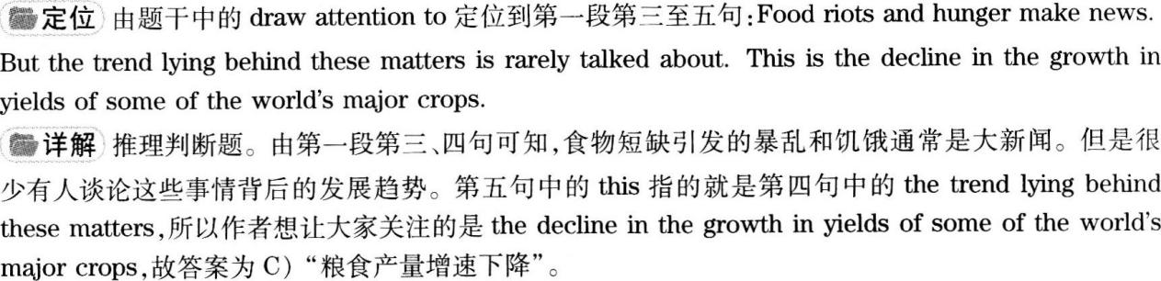



62．A.

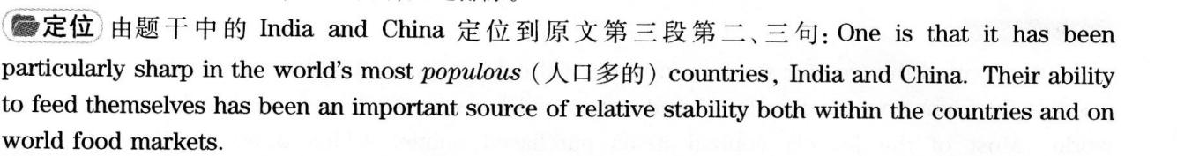

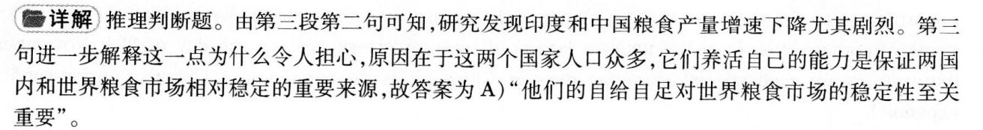



63．D.

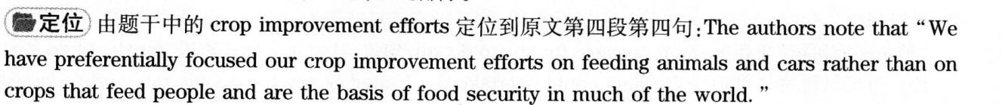





64．D.



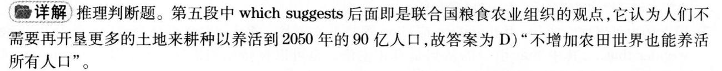



65．B.



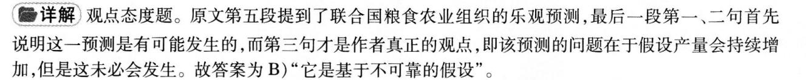





yield



aSSUme



stability



take…for granted认为……是理所当然的

reVerSe



account for占(比例]

Part IV Translation



It ls reported that courier services in China will deriver about l2 billion parcels this year，which makes it

possible for China to overtake the United States and become the largest market for courier services in the

world· Most of the parcels contain items purchased online． China offers millions of online retailers

opportunities to sell their products at significantly competitive prices．Chinese consumers bought$9 billion

worth of commodities from the nation’S largest shopping platform just on the day of 11th November．Since

there are many such special shopping days in China，it is no wonder that China’s courier services have

expanded．



1.第一句中，“据报道”译为It is reported that…。“120亿”译为l2 billion，这里应注意英文中的数字与汉语中的数字表达的差异。“包裹”可以用parcel或package等词来表达。

2.在翻译第二句时，由于该句与第一句关系密切，故可以将该句处理为一个由which引导的非限制性定语从句。“使……有可能”采用make it possible for sb．to do sth．句式，其中it是形式宾语，for sb．to do sth．是直_F宾语。也可以将该句单独译为China could overtake the United States to become the world，s largest eXDress delivery market．

3.第三句中，“装着”可译为contain，be filled with或be舢of。‘‘网上订购的物品，，译为items purchased／ ordered online，英语中过去分词短语作定语修饰名词时后置。

4.第四句中，“给……零售商……的机会”译法较多，可以用0ffer sb．sth．或provide sth．to sb．，即译为China provides opportunities to millions of online retailers to sell goods at significantly competitive prices.

5.在翻译第五句时，应注意英文中习惯将时间状语放在句尾，因此需要调整语序。如果为了强调，也可以置于句首。“从国内最大的购物平台购买了价值90亿美元的商品”也可以意译为spent$9 billion on the largest shopping platform of the nation。

6.第六句和第七句是明显的因果关系，因此可以利用连词since将两句合并为一句。第六句中“有，，的含义是“存在，而不是”拥有”，因此本句最好用there be句型。

7.第七句也可以独立成句，用therefore或thus等与上文衔接。第七句中‘‘不足为奇”可译为It／There is no wonde。that…，其中that引导的从句是真正主语。也可以保持原句语序，译为The e即ansion of China，s express industry is not surprising at all．